Faculty Submitting: Allison Kelly
Specify here whether “Pre” or “End” of Unit and the Unit #: Pre Unit 2
LOs: Distinguish elements from compounds, pure substances from mixtures, homogeneous from heterogeneous mixtures (solutions), and physical from chemical properties
Write formulas and names for elements, cations and anions, oxoacids, and ionic and covalent compounds
Describe the properties of protons, neutrons, electrons, atoms, ions and isotopes
Unit 2_ Question 1 | Canvas Question Type: Multiple Choice  QUESTION GROUP
1a | Which of the following represents a mixture?  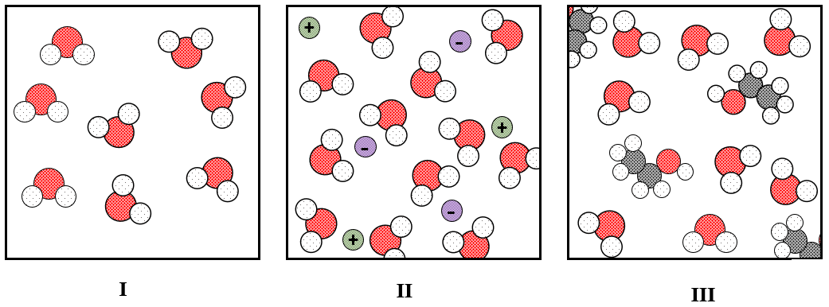  ALT TEXT: There are three boxes representing a microscopic system. The box labelled I has only water molecules in it. The box labelled II has water molecules, anions and cations. The box lablled III has water molecules and ethanol molecules.
Correct Answer: II and III
Wrong Answers:
Only I
Only II
Only III
I and II
I and III
1b | Which of the following represents a pure substance?  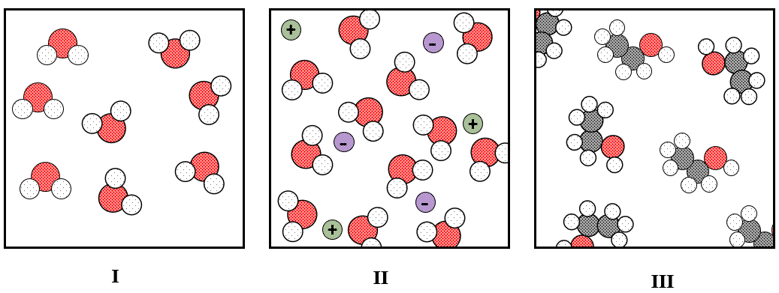  ALT TEXT: There are three boxes representing a microscopic system. The box labelled I has only water molecules in it. The box labelled II has water molecules, anions and cations. The box lablled III has water molecules and ethanol molecules.
Correct Answer: Only II
Wrong Answers:
Only I
Only III
II and III
I and II
I and III
Read More | https://openstax.org/books/chemistry-2e/pages/1-2-phases-and-classification-of-matter
Unit 2_ Question 2 | Canvas Question Type: Multiple Fill in the Blank
 | Elements cannot be broken down by [chemical] changes. [Compounds] are pure substances made of two or more elements.
Read More | https://openstax.org/books/chemistry-2e/pages/1-2-phases-and-classification-of-matter#CNX_Chem_01_02_MattType
Unit 2_ Question 3 | Canvas Question Type: Multiple Answers  QUESTION GROUP
3a | Which of the following are physical properties?
Correct answers:
Density
Melting point
Hardness
Wrong Answers:
Toxicity
Acidity
Flammability
3b | Which of the following are chemical properties?
Correct answers:
Toxicity
Acidity
Flammability
Wrong Answers
Density
Melting point
Hardness
Read More | https://openstax.org/books/chemistry-2e/pages/1-3-physical-and-chemical-properties
Unit 2_ Question 4 | Canvas Question Type: Matching
Atomic Number: The number of protons in an atom
Mass Number: The number of protons and neutrons in an atom
Atomic Mass: The mass of an atom
Read More | https://openstax.org/books/chemistry-2e/pages/2-3-atomic-structure-and-symbolism
Unit 2_ Question 5 | Canvas Question Type: Fill in Multiple Blanks
According to Dalton’s Postulates
A compound consists of [atoms] of two or more elements combined in a small, [whole]-number ratio. For a given compound, the atoms are always present in the same [ratio].
Read More | https://openstax.org/books/chemistry-2e/pages/2-1-early-ideas-in-atomic-theory
Unit 2_ Question 6 | Canvas Question Type: Matching
Match the laws to their definitions
Law of Constant Proportions – The elements of a compound are present in fixed proportions
Law of Conservation of Mass – Mass is neither created or destroyed
Read More | https://openstax.org/books/chemistry-2e/pages/2-1-early-ideas-in-atomic-theory
Unit 2_ Question 7 | Canvas Question Type: Multiple Choice  QUESTION GROUP
7a | Which of the following was the result of J.J. Thompson’s Cathode Ray Experiment?
Correct Answer: Observed electrons and determined the charge to mass ratio
Wrong Answers:
Demonstrated the existence of the nucleus of the atom
Determined the charge on the electron
7b | Which of the following was the result of R.A. Millikan’s Oil Drop Experiment?
Correct Answer: Determined the charge on the electron
Wrong Answers:
Observed electrons and determined the charge to mass ratio
Demonstrated the existence of the nucleus of the atom
7c | Which of the following was the result of Rutherford’s Gold Foil Experiment?
Correct Answer: Demonstrated the existence of the nucleus of the atom
Wrong Answers:
Observed electrons and determined the charge to mass ratio
Determined the charge on the electron
Read More | https://openstax.org/books/chemistry-2e/pages/2-2-evolution-of-atomic-theory
Unit 2_ Question 8 | Canvas Question Type: Multiple Drop Downs
Isotopes are atoms that contain the same number of [dropone] but different numbers of [droptwo]
DropOne
Correct Answer: protons
Wrong Answers: electrons, neutrons
DropTwo
Correct Answer: neutrons
Wrong Answers: protons, electrons
Read More | https://openstax.org/books/chemistry-2e/pages/2-3-atomic-structure-and-symbolism
Unit 2_ Question 9 | Canvas Question Type: Multiple Choice
For which of the following compounds is the empirical formula the same as the molecular formula?
Correct Answer: C₂H₆O
Wrong Answers:
C₆H₁₂O₆
C₆H₁₄
N₂O₂
Read More | https://openstax.org/books/chemistry-2e/pages/2-4-chemical-formulas
Unit 2_ Question 10 | Canvas Question Type: Multiple Answers
Which of the following are true for ionic compounds?
Correct Answers:
Composed of a metal and a nonmetal
Solids with high melting temperatures
Conduct electricity when melted
Formed by transferring electrons
Wrong Answers:
Formed by sharing electrons
Read More | https://openstax.org/books/chemistry-2e/pages/2-6-ionic-and-molecular-compounds
Unit 2_ Question 11 | Canvas Question Type: Multiple Drop Downs
An anion has [dropone] electrons to become [droptwo] charged
A cation has [dropthree] electrons to become [dropfour] charged
Drop One
Correct Answer: gained
Wrong Answer: lost
DropTwo
Correct Answer: negatively
Wrong Anwer: positively
DropThree
Correct Answer: lost
Wrong Answer: gained
DropFour
Correct Answer: positively
Wrong Answer: negatively
Read More | https://openstax.org/books/chemistry-2e/pages/2-3-atomic-structure-and-symbolism

